Group 120 – Assignment 1 – PS4

Name | Roll Number | Contribution Percentage
BOLLAM MANINDRA | 2024AA05733 | 20%
ASHVINI SATISH BHOSALE | 2024AA05732 | 20%
KUMARI POONAM SURESH NEETA | 2024AA05075 | 20%
ABHIRAM BORIGE | 2024AA05909 | 20%
SASANE GAURI RAMESH | 2024AA05679 | 20%

Assignment Task - Parallel/Distributed ML Implementation
Objective:
You are expected to design a parallel/distributed machine learning solution by integrating foundational optimization techniques and GPU-accelerated tools, as described in the assignment problem statement. Your design should demonstrate your ability to evaluate trade-offs and system-level decisions for performance optimization in ML systems.
Problem Statement 4: Distributed Mini-Batch Neural Network Training with PyTorch and Horovod
Build a Multi-Layer Perceptron (MLP) from scratch or using PyTorch for a classification task for MNIST Digit Classification Dataset.
Extend this to:
- Implement mini-batch training
- Use Horovod or DDP (DistributedDataParallel) to scale across multiple workers or GPUs (even if simulated)
- Track per-epoch time and communication overhead
Understand synchronization challenges in neural network training and how distributed execution improves training throughput.
You are required to prepare a design document as part of your assignment submission. Please address the following sections in detail:

1. Design Overview [3 Marks]
Chosen strategy: Data Parallelism using PyTorch DistributedDataParallel (DDP) as primary implementation.
Why Data Parallelism?
The MLP for MNIST is a parameter-sharing neural network where each worker can compute the forward/backward pass for different mini-batches independently. Data parallelism naturally scales by replicating the model across GPUs and splitting the input data across workers.
Task parallelism (splitting different functions among workers) is less effective for synchronous SGD because gradient updates must be synchronized across parameters, this creates a natural point for data-parallel aggregation.
A hybrid approach (data + model sharding) is unnecessary for a small MLP / MNIST task. For very large models model sharding would become relevant.

2. System Architecture Diagram [3 Marks]
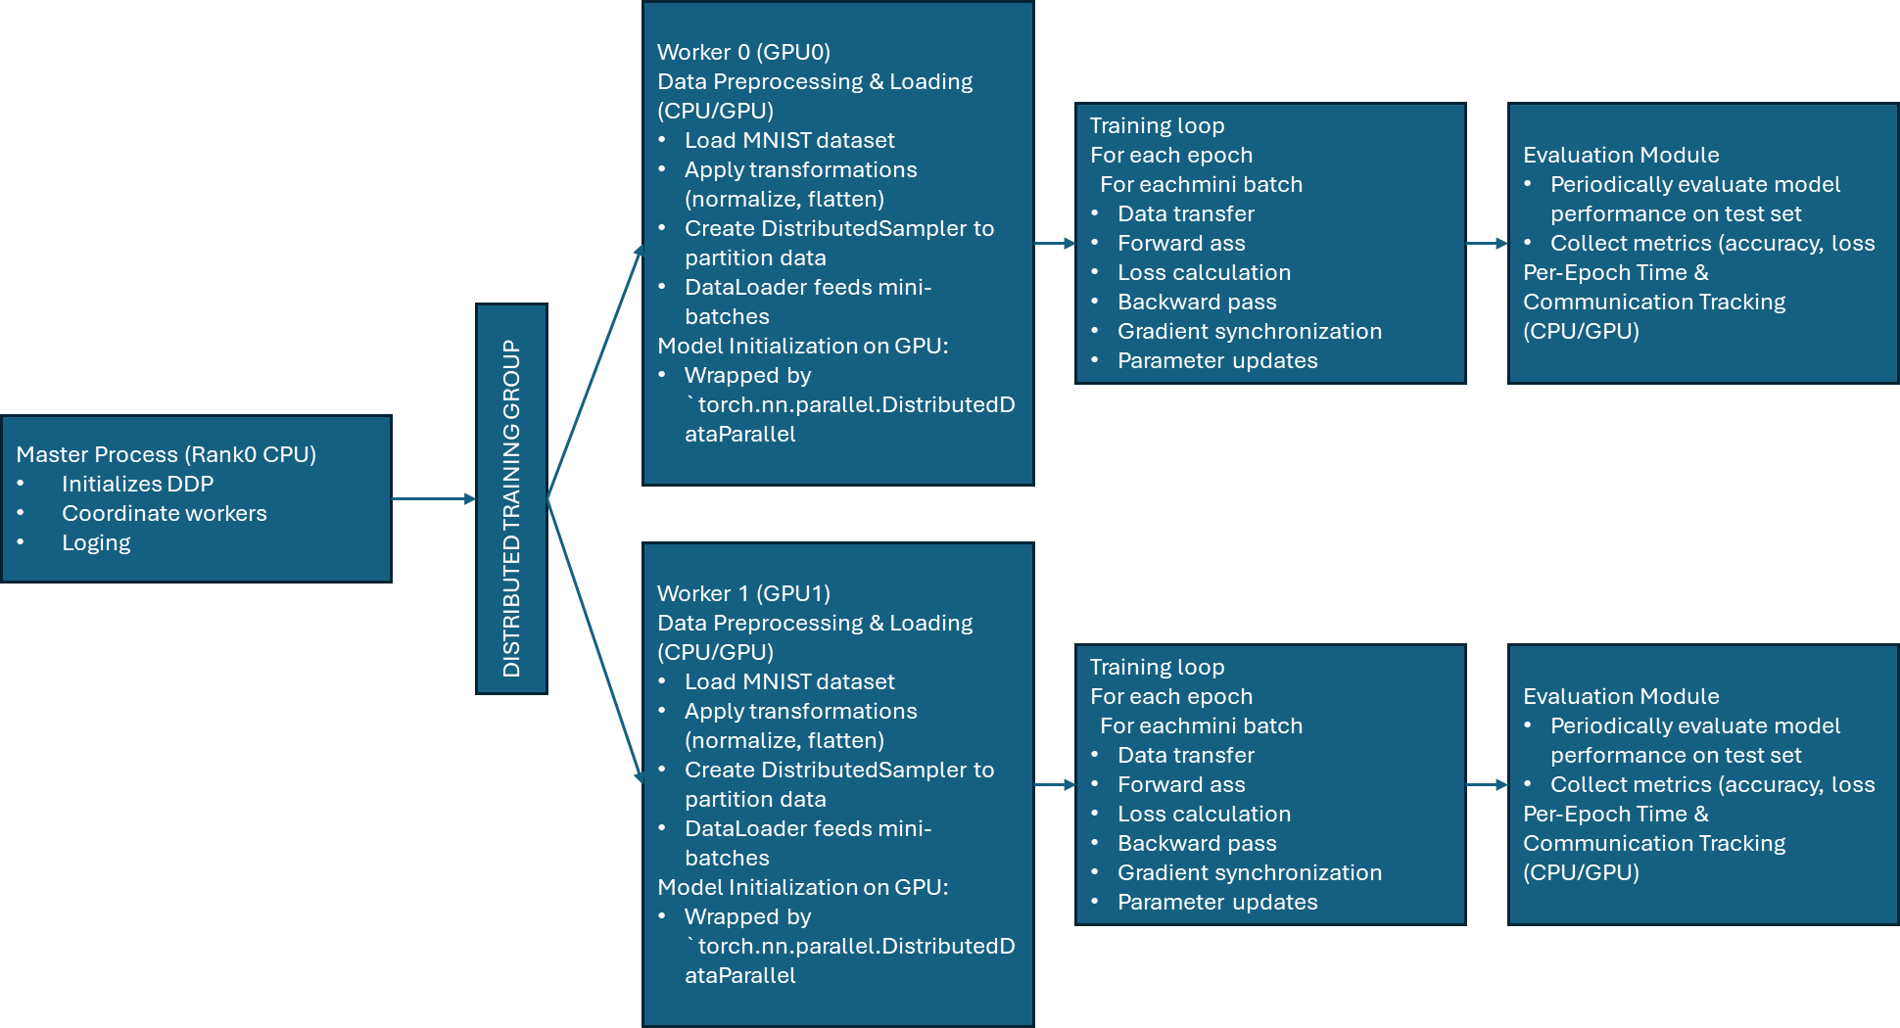
Horizontal view:

Vertical view:

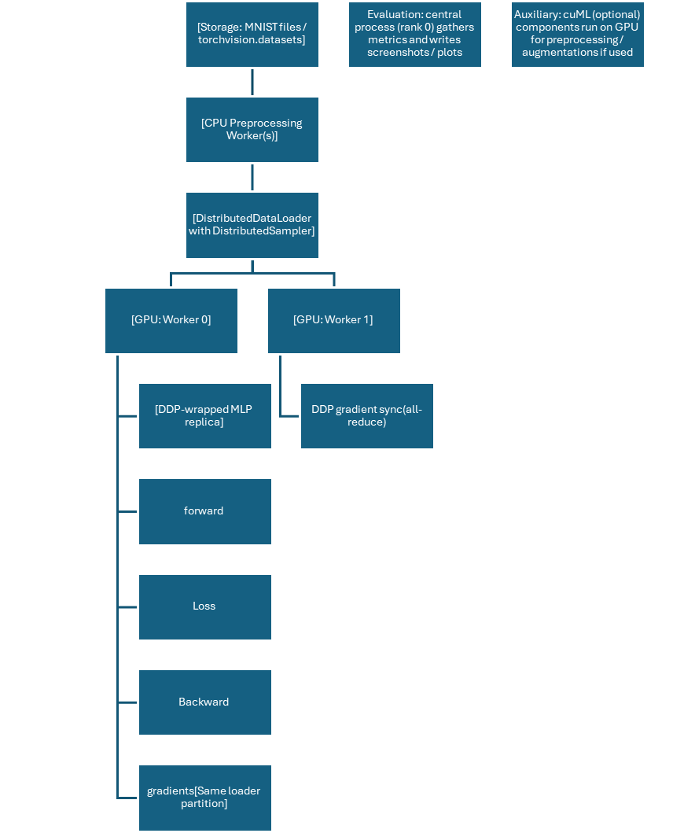

- Central Coordinator (Rank 0 Process): One designated process, typically rank 0, assumes responsibility for orchestrating the distributed training. This includes initializing the distributed environment, potentially loading the full dataset before sharding, managing overall training loop progression, and crucially, handling the saving of model checkpoints and logging of aggregated metrics.
- Data Preprocessing Module: This module, primarily executing on the CPU, manages the loading of the MNIST dataset, applies necessary transformations (e.g., ToTensor, normalization), and prepares the data for mini-batching. For distributed training, DistributedSampler ensures that each worker receives a unique, non-overlapping subset of the data.
- Worker Processes (GPU-accelerated): Each worker process:
  - Loads its assigned data shard using a DataLoader integrated with DistributedSampler.
  - Replicates the MLP model onto its dedicated GPU.
  - Performs independent forward and backward passes for its local mini-batches.
  - Computes local gradients based on its data subset.
  - Participates in the collective gradient synchronization (All-Reduce) operation to obtain global averaged gradients.
  - Updates its local model parameters using these synchronized global gradients.
- Evaluation Module: Periodically, a designated worker (typically rank 0) performs model evaluation on a validation or test set to track convergence, accuracy, and other performance metrics.
- Logging and Monitoring Module: This module collects and logs various performance metrics, including per-epoch training time, loss, accuracy, and communication overhead, primarily from the rank 0 process to avoid redundant outputs.
Execution pathways CPU vs GPU
- CPU: data download, decoding, CPU transforms (e.g. random crop, normalization) and prefetching.
- GPU: model weights, forward/backward, optimizer state (optionally). Pin-memory, prefetch to GPU.

3. Parallelization Strategy [3 Marks]
Method: Data Parallelism via DDP (PyTorch) - replicate model across N workers/GPUs. Each worker processes unique mini-batches using distributed sampler to avoid duplicate samples.
Mini-batches handling
- batch_size denotes local batch per worker. Effective global batch = batch_size * world_size.
- Use torch.utils.data.distributed.DistributedSampler(dataset, num_replicas=world_size, rank=rank) in training DataLoader.
Gradient updates & parameter synchronization
- DDP synchronizes gradients with an all-reduce (NCCL backend for GPUs) during backward pass. After backward, each replica has averaged gradients; optimizer.step() updates local weights which are now consistent across workers.
- To reduce communication overhead:
  - Use larger local batch_size (trade-off: memory).
  - Use gradient accumulation (accumulate multiple mini-batches locally then sync) via model.no_sync() context and sync only every k steps.
  - Use mixed precision training (AMP) to reduce memory and communication size.
  - Use gradient bucketing / optimizer offloading in advanced setups.

The DistributedSampler in PyTorch is a critical component for ensuring correct and efficient data distribution in data parallelism, preventing data duplication and guaranteeing full dataset coverage across workers. Without the DistributedSampler, each worker's DataLoader might load the same data batches, leading to redundant computation and incorrect gradient updates, effectively negating the benefits of parallelism. DistributedSampler explicitly shuffles and distributes data such that each GPU gets a unique slice of the dataset. No sample is repeated, and training is much faster than on a single GPU. This mechanism is fundamental for achieving true parallel speedup and maintaining the statistical properties of the training process, which are essential for model convergence and generalization.
Mini-batch training will be implemented by loading data in small, manageable batches using PyTorch's DataLoader. Each worker process will independently load mini-batches from its assigned data subset. For synchronous distributed training, the effective global batch size for one optimization step is the local mini-batch size multiplied by the number of workers or GPUs.

4. Development Environment [3 Marks]
Category | Tool / Library / Specification | Version | Purpose
Programming Language | Python | 3.10+ | Core language for development.
ML Libraries | PyTorch | 2.0+ | For building the MLP, automatic differentiation, and GPU ops.
 | Horovod | 0.28+ | Framework for distributed deep learning.
Data Handling | torchvision | 0.15+ | To load and preprocess the MNIST dataset.
Visualization | Matplotlib, Tensorboard | - | For plotting results
Dataset | MNIST Digit Classification | - | Standard dataset(Training 60k, test -10k)
Preprocessing | torchvision | - | Normalize, ToTensor, optional augmentations

5. Execution Platform & Implementation [10 Marks]
Local multi-GPU machine
- CPU: 8 cores
- GPUs: 1x NVIDIA RTX A2000 (4 GB)
- OS: Windows 11
- CUDA: 2.3.0+cu118, cuDNN: compatible
Single-GPU (development): simulate multiple processes with --nproc_per_node=2 using a single GPU or use CPU-only gloo backend if GPU not available.
CUDA/cuML compatibility: if using cuML/ cuDF , ensuring matching cuML version for CUDA toolkit
Execution strategy
- Local batch size per worker (example): 64
- Optimizer: SGD or Adam (lr tuned for global batch size)
- Number of workers (DataLoader): 4 CPU workers for data loading per process
- Number of GPUs/workers: world_size = number of processes launched (e.g., 2)
PyTorch DDP Integration:
- Initialize the process group: dist.init_process_group(backend="nccl"). NCCL is the backend for GPU-accelerated training due to its high performance.
- Pin the GPU to the current process: torch.cuda.set_device(local_rank).
- Wrap the model: model = DDP(model, device_ids=[local_rank]).
- Use DistributedSampler with DataLoader to ensure data sharding.
- Destroy the process group at the end of training: dist.destroy_process_group().
- Launch multiple processes using torch.multiprocessing.spawn or torchrun.
A standard PyTorch training loop will be implemented. For each epoch, the DistributedSampler will ensure each worker receives a unique subset of the dataset. The DataLoader will then provide mini-batches. The loop will involve:
- Zeroing gradients: optimizer.zero_grad().
- Forward pass: outputs = model(inputs).
- Loss calculation: loss = criterion(outputs, labels).
- Backward pass: loss.backward()
- Optimizer step: optimizer.step().

CODE:

import os import os
import platform
import time
import argparse
from typing import Tuple

import torch
import torch.nn as nn
import torch.optim as optim
import torch.distributed as dist
from torch.nn.parallel import DistributedDataParallel as DDP
from torch.utils.data import DataLoader, DistributedSampler
from torchvision import datasets, transforms

# ---------------------
# Model
# ---------------------
class MLP(nn.Module):
def __init__(self):
super().__init__()
self.net = nn.Sequential(
nn.Flatten(),
nn.Linear(28 * 28, 512),
nn.ReLU(),
nn.Linear(512, 256),
nn.ReLU(),
nn.Linear(256, 10),
)

def forward(self, x):
return self.net(x)

# ---------------------
# Distributed init
# ---------------------

def select_backend() -> str:
on_windows = platform.system().lower().startswith("win")
nccl_ok = hasattr(dist, "is_nccl_available") and dist.is_nccl_available()
if torch.cuda.is_available() and nccl_ok and not on_windows:
return "nccl"
return "gloo"

def maybe_init_dist() -> Tuple[int, int, int, str]:
world_size = int(os.environ.get("WORLD_SIZE", 1))
rank = int(os.environ.get("RANK", 0))
local_rank = int(os.environ.get("LOCAL_RANK", 0))
if world_size > 1 and not dist.is_initialized():
backend = select_backend()
dist.init_process_group(backend=backend)
else:
backend = "none"
return rank, world_size, local_rank, backend

# ---------------------
# Data
# ---------------------

def build_loaders(batch_size: int, world_size: int, rank: int, num_workers: int):
transform = transforms.Compose([
transforms.ToTensor(),
transforms.Normalize((0.1307,), (0.3081,)),
])
train_ds = datasets.MNIST(root="data", train=True, download=True, transform=transform)
test_ds = datasets.MNIST(root="data", train=False, download=True, transform=transform)

if world_size > 1:
train_sampler = Dis import os
import platform
import time
import argparse
from typing import Tuple

import torch
import torch.nn as nn
import torch.optim as optim
import torch.distributed as dist
from torch.nn.parallel import DistributedDataParallel as DDP
from torch.utils.data import DataLoader, DistributedSampler
from torchvision import datasets, transforms

# ---------------------
# Model
# ---------------------
class MLP(nn.Module):
def __init__(self):
super().__init__()
self.net = nn.Sequential(
nn.Flatten(),
nn.Linear(28 * 28, 512),
nn.ReLU(),
nn.Linear(512, 256),
nn.ReLU(),
nn.Linear(256, 10),
)

def forward(self, x):
return self.net(x)

# ---------------------
# Distributed init
# ---------------------

def select_backend() -> str:
on_windows = platform.system().lower().startswith("win")
nccl_ok = hasattr(dist, "is_nccl_available") and dist.is_nccl_available()
if torch.cuda.is_available() and nccl_ok and not on_windows:
return "nccl"
return "gloo"

def maybe_init_dist() -> Tuple[int, int, int, str]:
world_size = int(os.environ.get("WORLD_SIZE", 1))
rank = int(os.environ.get("RANK", 0))
local_rank = int(os.environ.get("LOCAL_RANK", 0))
if world_size > 1 and not dist.is_initialized():
backend = select_backend()
dist.init_process_group(backend=backend)
else:
backend = "none"
return rank, world_size, local_rank, backend

# ---------------------
# Data
# ---------------------

def build_loaders(batch_size: int, world_size: int, rank: int, num_workers: int):
transform = transforms.Compose([
transforms.ToTensor(),
transforms.Normalize((0.1307,), (0.3081,)),
])
train_ds = datasets.MNIST(root="data", train=True, download=True, transform=transform)
test_ds = datasets.MNIST(root="data", train=False, download=True, transform=transform)

if world_size > 1:
train_sampler = DistributedSampler(train_ds, num_replicas=world_size, rank=rank, shuffle=True)
test_sampler = DistributedSampler(test_ds, num_replicas=world_size, rank=rank, shuffle=False, drop_last=False)
else:
train_sampler = None
test_sampler = None

train_loader = DataLoader(
train_ds,
batch_size=batch_size,
shuffle=(train_sampler is None),
sampler=train_sampler,
num_workers=num_workers,
pin_memory=True,
persistent_workers=num_workers > 0,
)
test_loader = DataLoader(
test_ds,
batch_size=batch_size,
shuffle=False,
sampler=test_sampler,
num_workers=max(0, num_workers // 2),
pin_memory=True,
persistent_workers=(num_workers // 2) > 0,
)
return train_loader, test_loader, train_sampler

# ---------------------
# Train / Eval
# ---------------------

def evaluate(model: nn.Module, loader: DataLoader, device: torch.device) -> float:
model.eval()
correct = 0
total = 0
with torch.no_grad():
for x, y in loader:
x = x.to(device, non_blocking=True)
y = y.to(device, non_blocking=True)
logits = model(x)
pred = logits.argmax(dim=1)
correct += (pred == y).sum().item()
total += y.size(0)
return 100.0 * correct / max(1, total)

def train(args):
rank, world_size, local_rank, backend = maybe_init_dist()

# Device policy: only use GPU when NCCL backend is active (Linux multi-GPU). Otherwise use CPU.
use_gpu = backend == "nccl"
device = torch.device(f"cuda:{local_rank}" if use_gpu else "cpu")

# Data
train_loader, test_loader, train_sampler = build_loaders(
batch_size=args.batch_size,
world_size=world_size,
rank=rank,
num_workers=args.workers,
)

# Model & optimizer
model = MLP().to(device)
if world_size > 1:
ddp_model = DDP(model, device_ids=[local_rank] if use_gpu else None)
else:
ddp_model = model

criterion = nn.CrossEntropyLoss()
optimizer = optim.SGD(ddp_model.parameters(), lr=args.lr * max(1, world_size), momentum=0.9)
scaler = torch.amp.GradScaler(device="cuda") if (args.amp and use_gpu) else None

epoch_times, comm_times = [], []

for epoch in range(args.epochs):
if train_sampler is not None:
train_sampler.set_epoch(epoch)
ddp_model.train()

epoch_start = time.time()
comm_time = 0.0

optimizer.zero_grad(set_to_none=True)

for step, (x, y) in enumerate(train_loader, start=1):
x = x.to(device, non_blocking=True)
y = y.to(device, non_blocking=True)

# Optional gradient accumulation
maybe_no_sync = (
(world_size > 1) and (args.grad_accum_steps > 1) and (step % args.grad_accum_steps != 0)
)

ctx = ddp_model.no_sync() if maybe_no_sync else torch.no_grad() if False else None
# Simple context manager shim
class _NullCtx:
def __enter__(self):
return None
def __exit__(self, exc_type, exc, tb):
return False
if ctx is None:
ctx = _NullCtx()

step_start = time.time()
with ctx:
if scaler is not None:
with torch.autocast(device_type="cuda", dtype=torch.float16):
logits = ddp_model(x)
loss = criterion(logits, y) / args.grad_accum_steps
scaler.scale(loss).backward()
else:
logits = ddp_model(x)
loss = criterion(logits, y) / args.grad_accum_steps
loss.backward()

# Communication happens during backward on synced steps. we approximate comm time as time after backward
if use_gpu:
torch.cuda.synchronize()
after_backward = time.time()

do_step = (step % args.grad_accum_steps == 0)
if do_step:
if scaler is not None:
scaler.step(optimizer)
scaler.update()
else:
optimizer.step()
optimizer.zero_grad(set_to_none=True)
if use_gpu:
torch.cuda.synchronize()
after_step = time.time()

comm_time += max(0.0, after_step - after_backward)

if rank == 0 and args.log_interval and step % args.log_interval == 0:
print(f"epoch {epoch} step {step}: loss={loss.item()*args.grad_accum_steps:.4f}")

epoch_end = time.time()
epoch_times.append(epoch_end - epoch_start)
comm_times.append(comm_time)

# Evaluation on rank 0
if rank == 0:
acc = evaluate(ddp_model if world_size == 1 else model, test_loader, device)
print(
f"Epoch {epoch}: epoch_time={epoch_times[-1]:.3f}s, comm_time_est={comm_times[-1]:.3f}s, test_acc={acc:.2f}%"
)

if rank == 0:
print("Per-epoch times:", [round(t, 3) for t in epoch_times])
print("Estimated comm times:", [round(t, 3) for t in comm_times])

if dist.is_initialized():
dist.destroy_process_group()

if __name__ == "__main__":
class Args:
def __init__(self):
self.epochs=20
self.batch_size=64
self.workers=4
self.lr=0.01
self.amp="store_action"
self.grad_accum_steps=1
self.log_interval=200
args = Args()
train(args)

OUTPUT SCREENSHOTS:
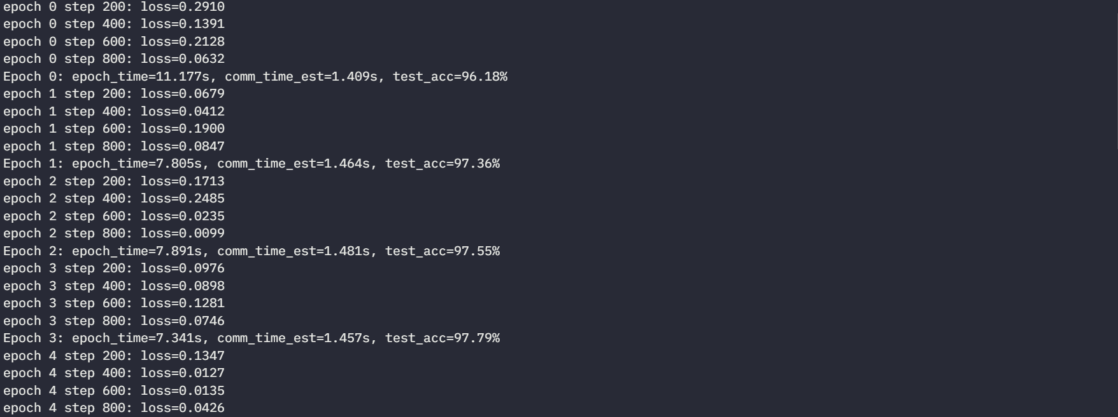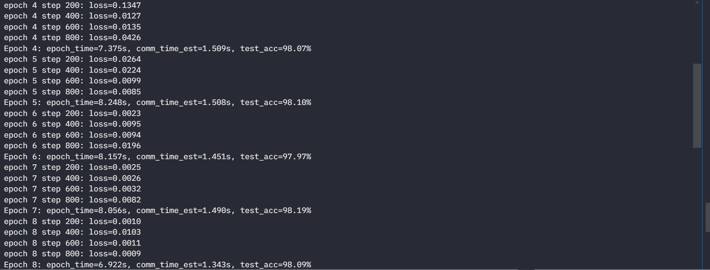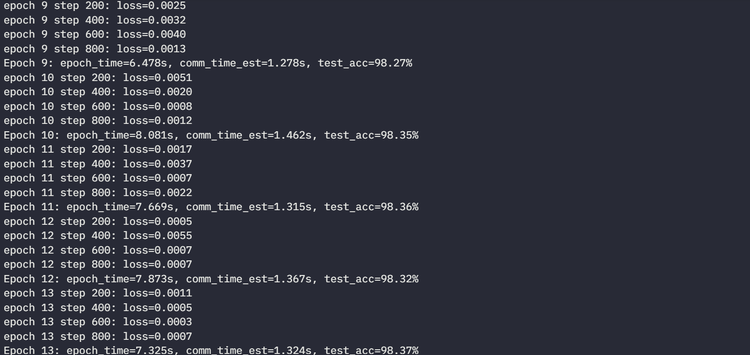

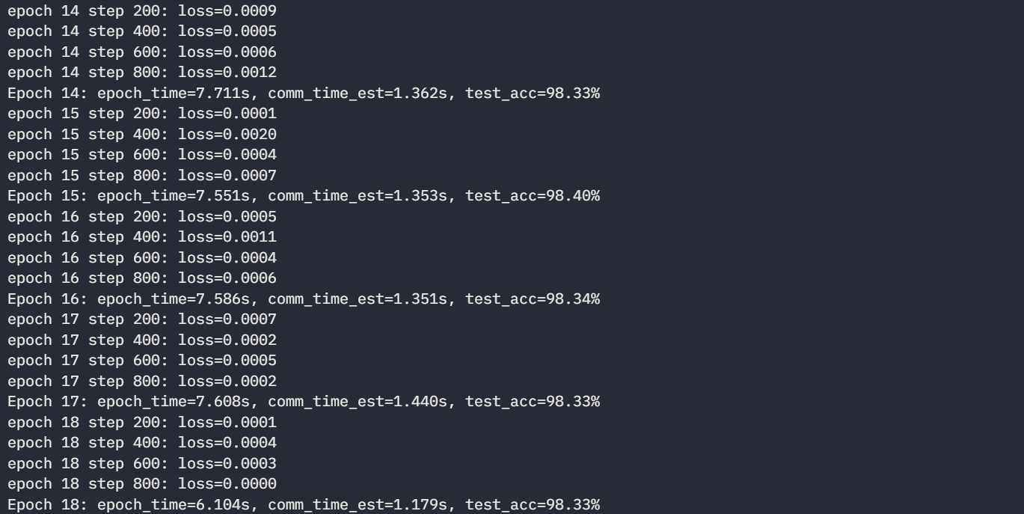

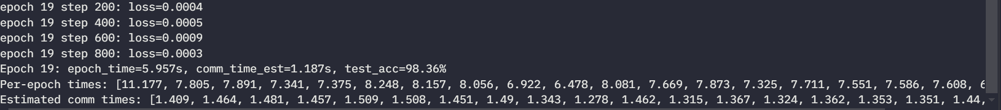

6. Initial Challenges Identified [3 Marks]

During the design and execution of distributed MLP training with PyTorch DDP, we faced the following challenges:
- Computation Bottlenecks
- Data loading on the CPU was sometimes slower than expected. Even with multiple DataLoader workers (num_workers), GPUs occasionally had to wait for data, especially when running with larger batch sizes.
- Although our preprocessing (ToTensor + Normalize) was lightweight, we realized that more complex transforms would have caused further delays on the CPU.
- Compatibility Issues
- Setting up the correct PyTorch + CUDA version combination required trial and error. Small mismatches caused runtime errors or prevented GPUs from being used effectively.
- Backend configuration (choosing between NCCL on Linux vs. Gloo on Windows) and environment variable setup (MASTER_ADDR, MASTER_PORT) took effort to get right before training would run smoothly.
- Communication Costs
- Gradient synchronization (all_reduce) added noticeable overhead during training. This effect grew with more processes, reducing some of the expected speed up.
- On a single GPU simulation, communication was minimal, but when scaling to multiple workers, network bandwidth clearly became a limiting factor.
- Even small costs like transferring mini-batches from CPU to GPU added up across epochs.
- Data Handling Overhead
- Loading the full MNIST dataset was manageable, but we recognized that scaling to larger datasets would stress memory and data sharding further. Streaming pipelines would be needed in such cases.
- DistributedSampler worked well for MNIST, but required careful handling to avoid uneven batches across workers.

